dat-shift AI: Product Feature Summary
The cognitive-predictive AI platform for critical buildings and command centers. dat-shift AI does more than predict faults. It understands the environment around every asset, correlates alarms, history and conditions, and judges which risks truly matter and why. AI agents then explain, act and help fix them, with people in control.

Positioning
Most data platforms collect and store data, then leave the hard work to people. dat-shift AI puts agentic AI at the heart of the data itself. Agents turn raw signals from BMS, fire, CCTV and IT systems into trusted, decision-ready intelligence, and then act on it.
- Others: storage, dashboards and manual data engineering.
- dat-shift AI: AI agents that understand, predict, explain and remediate.

How it works
- Connect: collects live data from building and IT systems across every site, through one secure, on-premise pipeline.
- Understand (agentic AI layer): AI agents work on the cleansed data, recognising equipment and points, mapping them to industry standards, enriching them with site and asset context, and flagging quality issues. Onboarding a new building takes days, not months.
- Curate: agents publish decision-ready intelligence sets, such as asset health, alarm patterns, fault response performance and spare-parts readiness, tailored to each use case.
- Predict and act: predictive models and AI agents turn that intelligence into early warnings, explained recommendations and approved fixes.

Core features

Cognitive-predictive AI (signature feature)
- Goes beyond prediction: forecasts likely faults, then correlates them with the surrounding environment, including recent alarms, maintenance history, weather, occupancy, related equipment and what the asset serves.
- Evaluates the contextual severity and operational impact of each risk, with the reasoning behind it, so faults affecting mission-critical or life-safety systems are always prioritised above minor ones.
- Pre-trained, domain-specific model library for HVAC, CCTV, servers and integration platforms.
- Generic models that work from day one, plus per-site learning of normal behaviour.
- Context-aware risk scores with the reasons and evidence behind them.

Agentic workflow automation
Automated workflows and AI agents work hand in hand across the end-to-end process for every fault, predicted fault or other critical condition. The workflow engine runs the process, timers and approvals; the AI agents provide context-aware decision intelligence at each step. People stay in control throughout.
Stage | Automated workflow | AI agent
1. Detect | Ingests live alarms and predicted-fault risk scores in real time | Correlates with surrounding context, confirms the fault or predicted fault, and rates its contextual severity
2. Notify and alert | Sends alerts by severity rules through the customer's channels, such as the incident management platform, mobile app, SMS, email or messaging apps such as WhatsApp or Telegram | Identifies which stakeholders need to know and writes a plain-language summary with evidence
3. Delegate | Creates and routes the work order, tracks acknowledgement and escalates automatically on timeout | Recommends the best available responder based on skills, location, workload and on-duty roster
4. Prepare and respond | Pushes the task to the responder's mobile app and broadcasts it to the relevant stakeholder group chats on messaging apps such as WhatsApp or Telegram, then tracks progress | Attaches the device profile, working drawings, required parts and troubleshooting steps
5. Monitor SLA risk | Tracks every stage against KPI and SLA targets | Forecasts likely delays, such as slow acknowledgement, a responder far from site, low spare-parts stock or long supplier lead times, and raises an early alert with a recovery action
6. Verify and close | Closes the work order once the fix is confirmed and records lifecycle KPIs | Verifies recovery from live data and learns from what was done
Task delegation works in two modes:
- Human-led: the AI recommends the responder and a supervisor confirms or reassigns in one click.
- AI-automated: for pre-approved, low-risk fault types, the agent delegates directly to the respective stakeholder on the ground and notifies the supervisor.
When the KPI is predicted to be at risk, the agent recommends recovery actions, such as reassigning to a nearer responder, expediting parts, sourcing from another site's stock or escalating to management, before the target is missed.

Real-time fault detection and correlation
- Integrates natively with the customer's existing incident management platform, forwarding fault alerts that need an incident response, through API-based, bi-directional connectors. dat-shift AI is not another incident management system; it adds intelligence to the one already in place, working with leading partner platforms.
- Equipment faults and abnormal conditions detected in real time from live device data and raised as fault alerts within seconds, on a dedicated path independent of analytics.
- Fault correlation traces related symptoms to a single root cause, for example several CCTV cameras going offline at the same time, traced to the PoE switch that powers them, and raises one enriched fault record with probable cause, priority and recommended actions attached.
- Easy integration through open APIs, webhooks and standard connectors, with no change to operators' existing workflows.
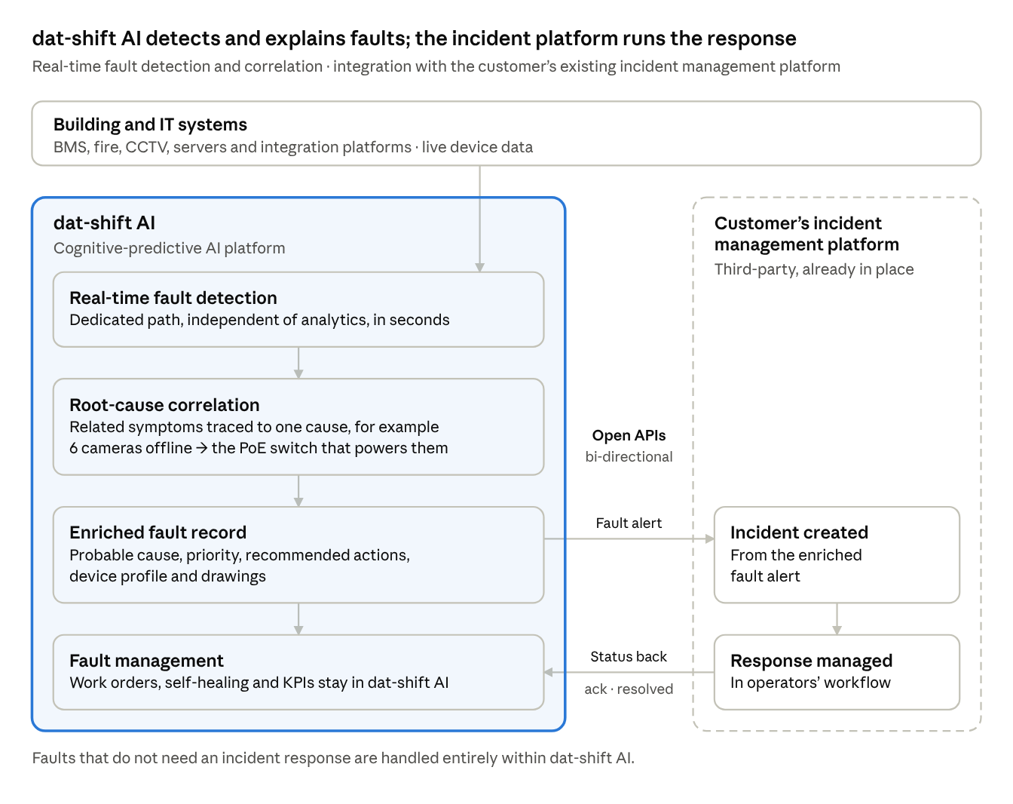
dat-shift AI and the customer’s incident management platform · data flow
dat-shift AI detects faults in real time, traces them to a root cause and builds an enriched fault record. Faults that need an incident response are sent to the customer’s existing platform through open APIs, and status updates flow back to dat-shift AI to complete the fault lifecycle KPIs.

Agentic data intelligence
- AI agents that read vendor point lists and map them to standards such as Brick and Haystack.
- Automatic cleansing, standardisation and context enrichment across multi-vendor sites.
- Human review of AI mappings for life-safety points.
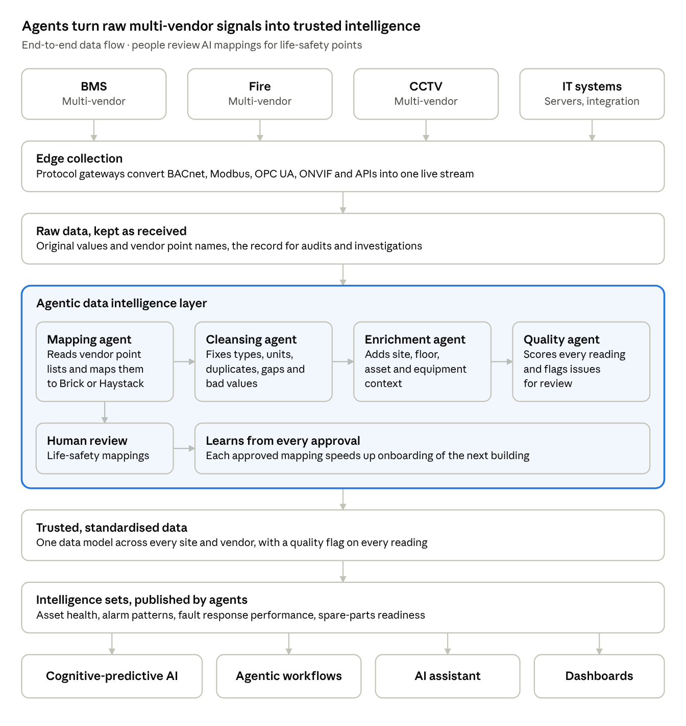
agentic data intelligence · end-to-end data flow
Data from every vendor's systems is collected once and kept as received. Four agents then map, cleanse, enrich and quality-check it, with people approving life-safety mappings, so every site shares one trusted data model that the AI features and dashboards build on.

Cognitive AI assistant
- Explains risks in plain language, with evidence and priority.
- Answers operator questions, such as which sites had repeated fire panel faults this month.
- Drafts fault summary reports and monthly SLA reports.
- Generates visual reports on request: users ask in plain language, such as "show chiller health across all sites this quarter", and the AI builds interactive charts and dashboard-style views, ready to refine, share or export.
- Intelligent work orders, sent once approved to the maintenance team or maintenance management system:
  - Right responder: assesses the fault type, asset, location, criticality, contracts and on-duty rosters to assign the right stakeholder, such as the in-house technician, OEM vendor, IT team or fire contractor, with escalation if unacknowledged.
  - Affected device profile: automatically pulls the faulty device's details in real time, including brand, model, serial number, firmware version, IP address, network location, current configuration, warranty and service history, so the technician has everything at hand without searching. Access is role-based: passwords, keys and other secrets are masked, sensitive configuration is shown only to authorised roles, and every view is logged.
  - Working drawings: attaches the relevant as-built drawings for the affected system, such as floor plan layouts showing the device location, schematic and single-line diagrams, and wiring or network topology drawings, so the technician can locate the device and trace the system quickly.
  - Diagnosis and evidence: likely root cause, confidence level, supporting trends and related alarms.
  - Recommended preparation: spare parts, tools, access permits, safety precautions and isolation steps to arrange before arriving on site.
  - Suggested troubleshooting steps: a step-by-step checklist drawn from runbooks, manuals and past fixes for similar faults.
  - Closure criteria: how to confirm the fix, such as readings back in range or alarms cleared, with the AI verifying recovery before the work order is closed.
  - Learning loop: captures what was actually done to improve future recommendations.
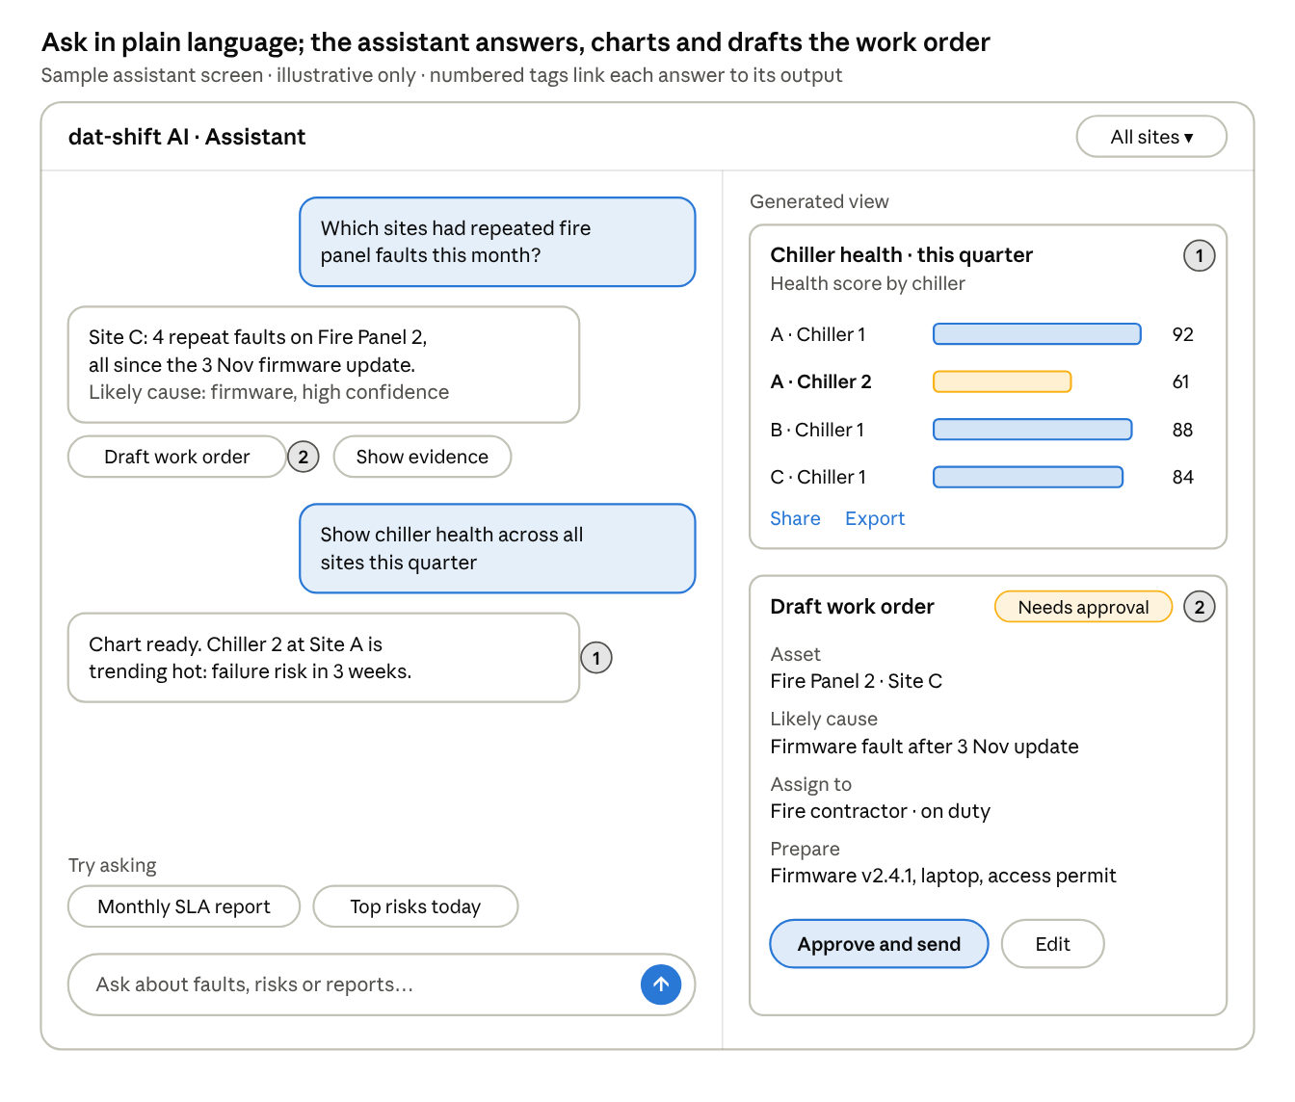
sample assistant screen · chat on the left, generated outputs on the right
Illustrative screen: users ask in plain language on the left. The assistant answers with evidence and a confidence level, offers one-tap next steps such as drafting a work order, and shows what it generates on the right, ready to share, export or approve.

Responder mobile app
- Field app for technicians and responders, giving the work order, device profile, working drawings and troubleshooting checklist on site.
- AI-assisted troubleshooting chatbot: responders describe what they see, and the AI guides them step by step using live readings, alarm history, manuals, runbooks and past fixes for similar faults.
- Live status of the affected equipment, so responders can confirm in real time whether each step worked.
- Update the work order from the field with notes, photos and parts used, feeding the fault lifecycle KPIs and the learning loop.
- Role-based access with the same masking of sensitive configuration as the main platform.
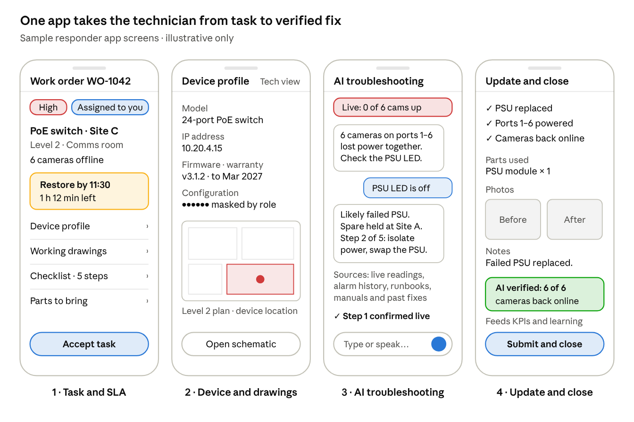
sample responder app · four screens from task to verified fix
Illustrative screens: the technician accepts the task with its SLA countdown, checks the device profile and its location on the floor plan, troubleshoots step by step with the AI assistant against live status, then records parts, photos and notes before the AI verifies recovery and the work order closes.

Fault lifecycle KPIs
- Timestamps every stage automatically, from the moment a fault is detected in real time (or reported) until the system is confirmed back to normal.
- Stages tracked: detected, routed to the right stakeholder, acknowledged, responder on site, fixed, verified back to normal, work order closed.
- Industry-standard measures: mean time to detect (MTTD), mean time to acknowledge (MTTA) and mean time to restore (MTTR), plus routing accuracy and first-time fix rate.
- A KPI score per fault, compared against SLA targets, rolled up by site, system type, contractor and shift.
- Shows where delays happen, such as slow acknowledgement or waiting for parts, and gives verified evidence for SLA and contractor performance reporting.
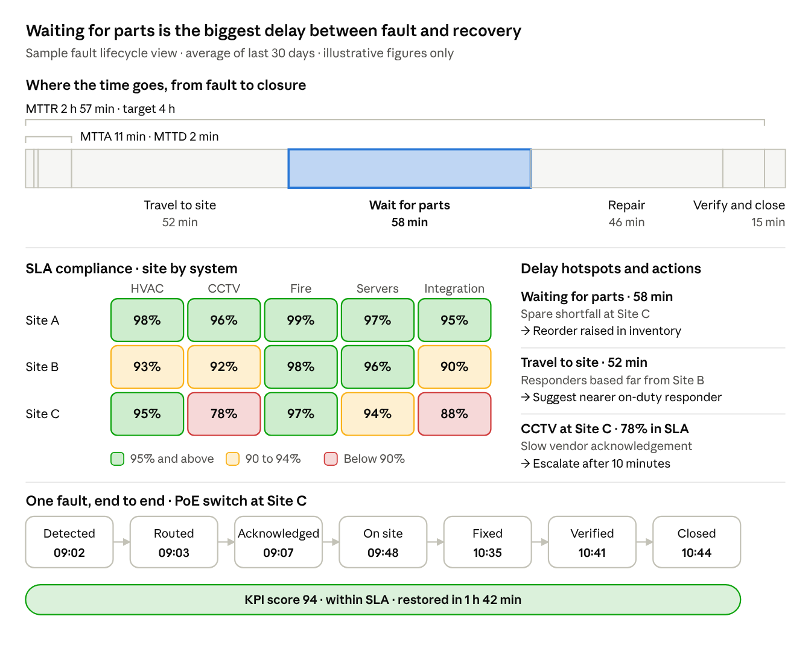
sample fault lifecycle dashboard · stages, SLA and one fault traced
Illustrative dashboard: every fault is timestamped stage by stage (bottom), which rolls up into MTTD, MTTA and MTTR and the time split across stages (top), and into SLA compliance by site and system (middle), with delay hotspots turned into actions. The stage view shows where delays happen, in this sample waiting for parts, which links back to asset and inventory intelligence.

Asset and inventory intelligence
- Asset register with each device's brand, model, location, age, warranty, lifecycle status and service history.
- Spare parts inventory with stock levels, locations, supplier lead times and minimum stock levels.
- Links predictions to inventory: when a failure is forecast in the coming weeks or months, agents check whether the right spares are in stock and can arrive in time.
- Forecasts parts demand from predicted failures across all sites and flags shortfalls early, with a suggested reorder quantity and date for approval.
- Highlights ageing or end-of-life assets and obsolete parts, supporting replacement planning and budgeting.
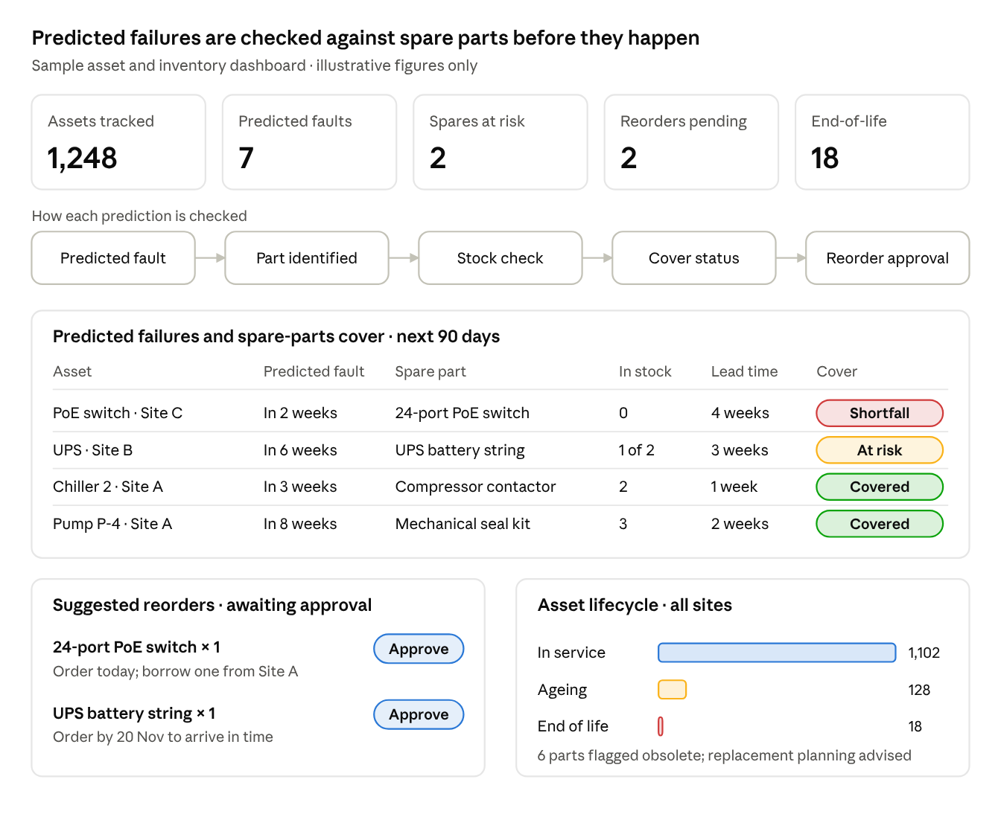
sample asset and inventory dashboard · predictions linked to spare parts
Illustrative dashboard: every predicted failure is traced to the spare part it needs, checked against stock and supplier lead time, and given a cover status. Shortfalls become suggested reorders for approval, and the lifecycle view flags ageing and end-of-life assets for replacement planning.

Smart maintenance calendar
- Central maintenance calendar organising preventive maintenance and routine checks for critical systems across all sites, focused on keeping them available and in service, viewable by site, system, team or responder.
- AI-recommended preventive maintenance: agents analyse run hours, condition trends, fault history, predicted risks and manufacturer recommendations to suggest what should be checked and when, moving from fixed intervals to condition-based maintenance.
- Auto-suggested rescheduling: brings forward checks on assets showing early signs of degradation and defers checks on healthy assets, with the reasons, for operator approval.
- Resource-aware planning: checks responder availability and spare-parts stock before scheduling, and bundles tasks at the same location to reduce site visits and downtime.
- Generates work orders and checklists automatically when tasks fall due, sends reminders, and tracks completed and overdue tasks for SLA compliance and system availability reporting.
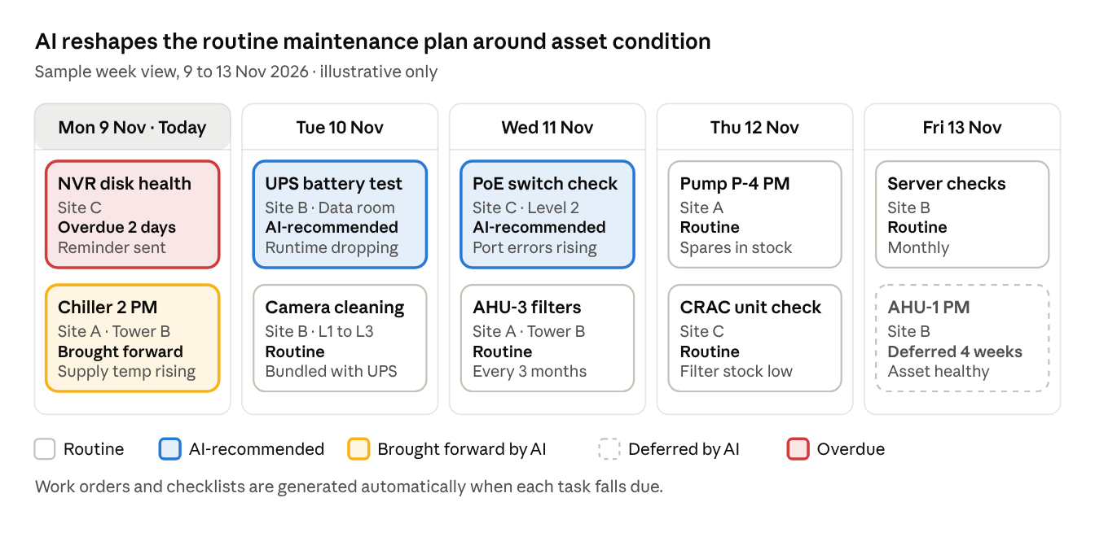
sample maintenance calendar · one week, five task types
Illustrative example: the AI recommends extra checks where condition data shows early warning signs, brings forward or defers routine tasks with reasons, bundles tasks at the same site, and flags overdue tasks and low spare-parts stock.

Self-healing AI
- Diagnoses faults and proposes fixes from a library of tested runbooks.
- Risk-tiered approvals: one-click for low risk, named approver for medium risk, never automatic for life-safety systems.
- Verifies recovery, rolls back automatically if needed, and keeps a full audit trail.
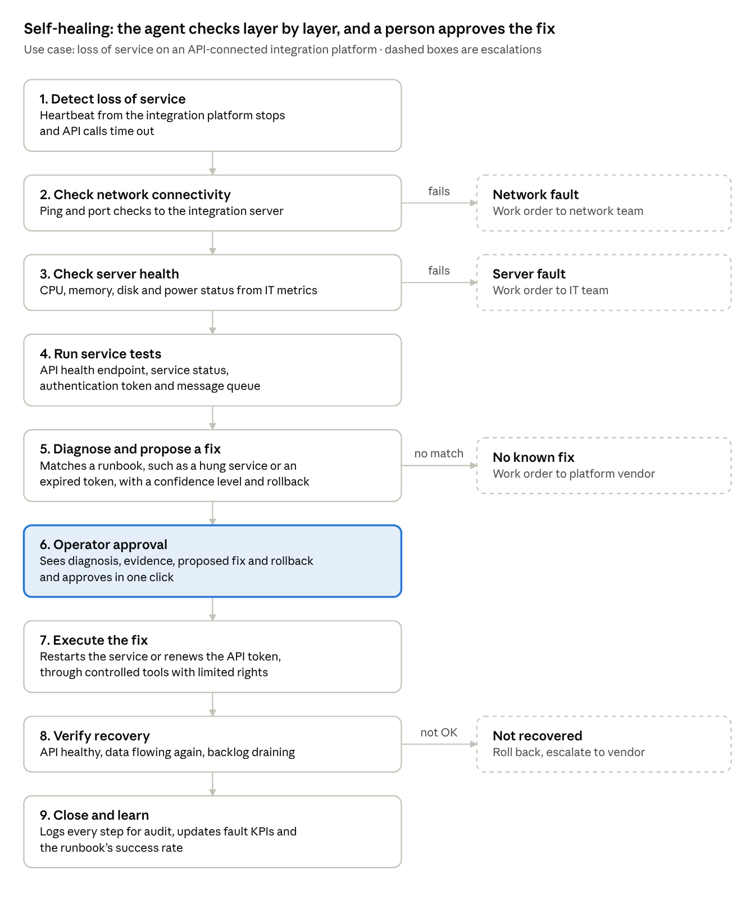
self-healing use case · loss of service on an integration platform, 9 steps
Illustrative use case: the agent rules out network and server faults before testing the integration service itself, proposes a known fix only when a runbook matches, and acts only after operator approval. Any failed check or failed recovery escalates to a work order for the right team.

Cybersecurity platform integration
- Integrates with the customer's existing cybersecurity platforms, such as SIEM, through API-based connectors. dat-shift AI does not monitor cyber threats or collect security logs itself.
- Consumes security alerts and events from the SIEM to enrich fault analysis, adding a cyber perspective to operational insights.
- Cross-domain correlation between operational faults and security events, for example an abnormal BMS setpoint change that coincides with a suspicious remote login flagged by the SIEM, so faults with a possible cyber cause are not treated as ordinary equipment faults.
- Shares operational context back to the SIEM, such as asset criticality, device details and OT fault events, for richer security investigations.
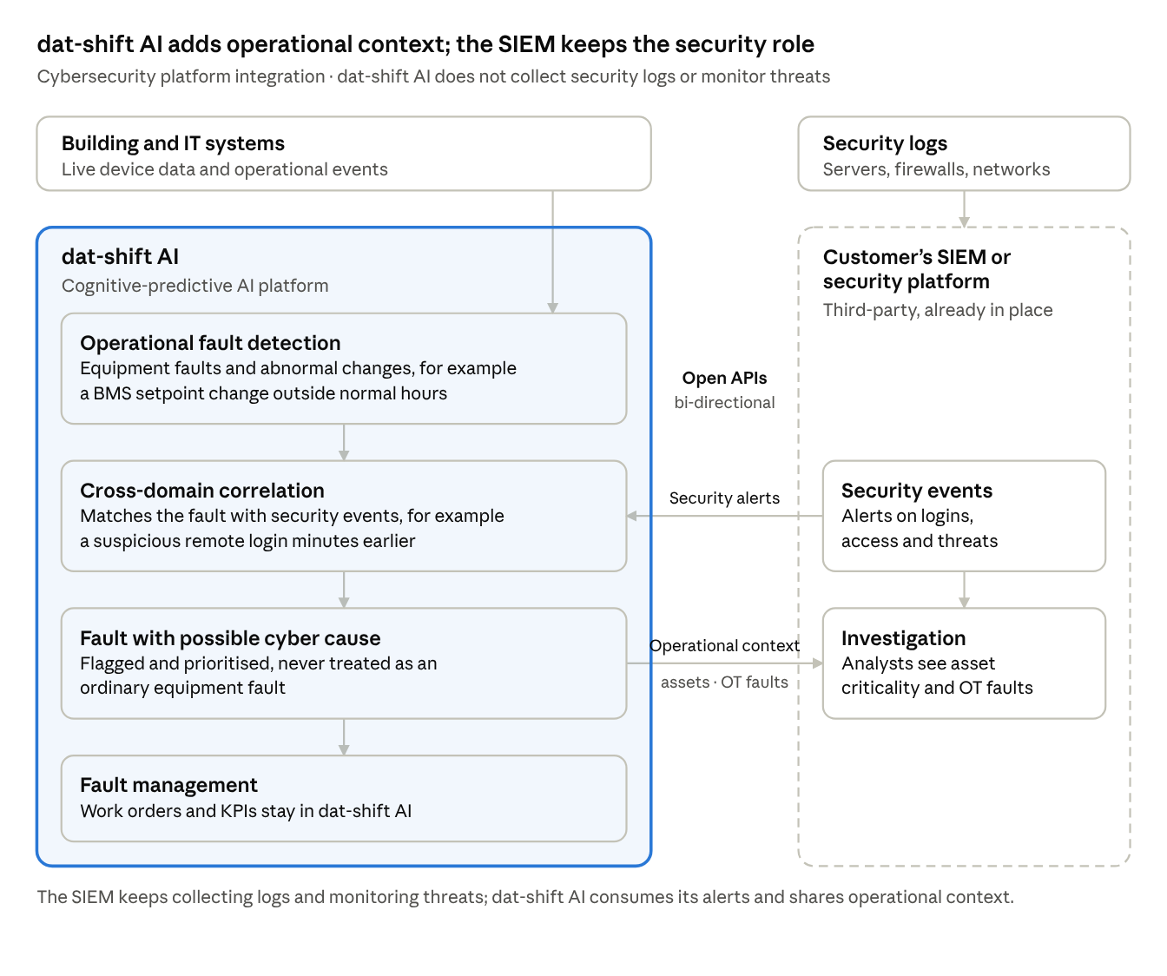
dat-shift AI and the customer’s SIEM · data flow
The SIEM keeps its security role. dat-shift AI takes its alerts through open APIs, correlates them with operational faults so that a fault with a possible cyber cause is flagged and prioritised, and sends asset criticality and OT fault context back to support security investigations.

Operational insights
- System availability readiness: availability of each critical system against target, and how ready each site is to keep it that way.
- SLA and KPI compliance: fault response and restoration times measured against agreed SLA and KPI targets, by site, system and contractor.
- Alarm rationalisation: nuisance and repeat alarms identified and reduced.
- CCTV health: camera and recorder uptime and recording gaps.
- Energy and sustainability: consumption tracked against targets.
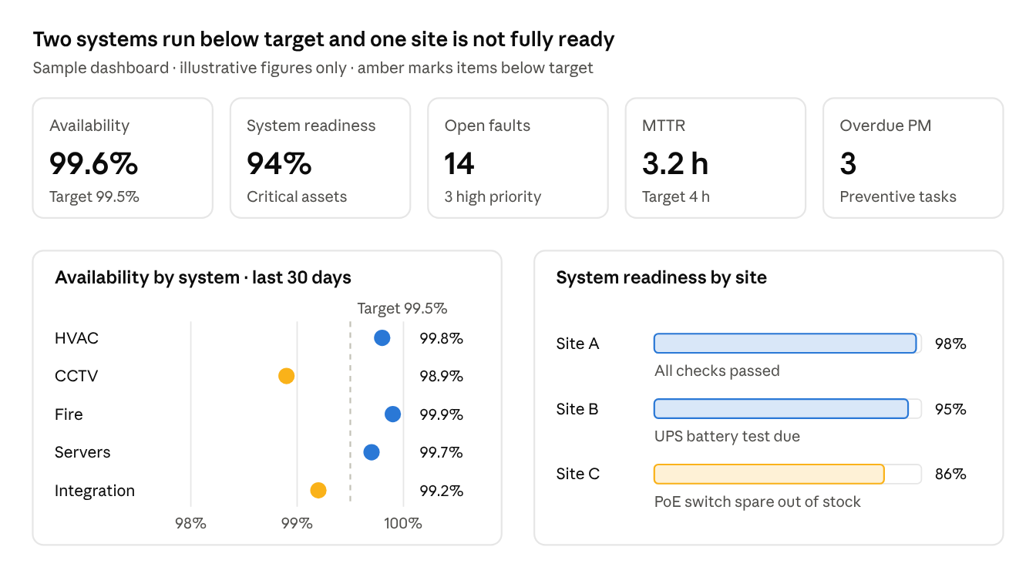
sample operational insights dashboard · availability and readiness
Illustrative dashboard: headline KPIs, availability of each critical system against target, and readiness of each site, with the reason behind any shortfall, such as a missing spare part or a test that is due.

Customer outcomes
- Fewer nuisance alarms and faster fault response.
- Failures caught early, before they disrupt operations.
- Faults resolved faster through approved self-healing.
- Faults with a possible cyber cause identified faster, through correlation with the customer's SIEM.
- One intelligent view across every site.

